HABITAT STEWARD APPLICATION FORM
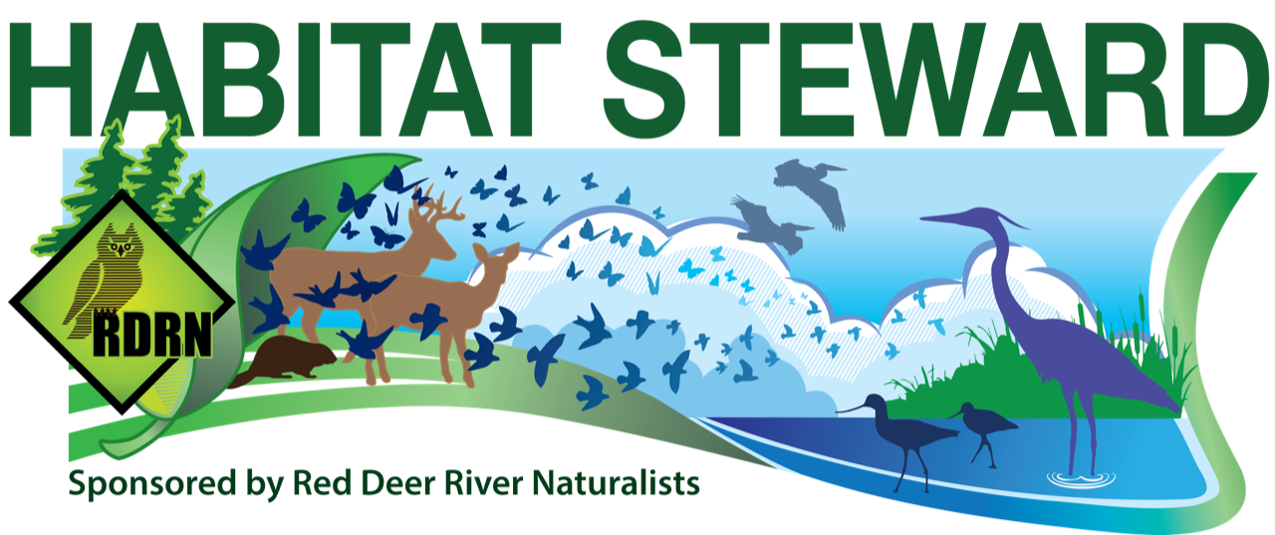
Thank you for applying to become a Red Deer River Naturalists Habitat Steward!
Please use additional pages if necessary.
OPTIONS: 1. Fill in, scan and email to Myrna Pearman at myrnapearman.nature@gmail.com
2. Fill in and mail to Red Deer River Naturalists Box 785, Red Deer AB T4N 5H2
Name |  |  |  |  |  |  |  |  |  |  |  | Date
Address |  | Street or Box Number
 |  | Town |  |  |  |  |  |  |  |  |  |  | P. Code
Telephone |  | Home |  |  |  |  |  |  |  | Cell
Email Address
Legal Land Description
Rural Address
How did you hear about the Habitat Steward Program?
If “other” above, please specify
If you were nominated, please share the name of the nominee
Would you like a gate sign? |  |  | ☐YES  ☐NO |  | Would you be willing to offer a tour of your property to local naturalists? |  |  |  |  | ☐YES  ☐NO |  | Would you be willing to be featured in a newspaper/magazine article or on social media? |  |  |  | ☐YES  ☐NO
May we contact you by email from time to time about the Habitat Steward program? |  |  |  |  |  |  |  | ☐YES  ☐NO |  | Does this area have any other protective designations (caveats, NCC, etc.) that you would like to share? |  |  |  |  | ☐YES  ☐NO  ☐RATHER NOT SAY
HABITAT DESCRIPTION
Total acres set aside as wildlife habitat
Acres of Grassland |  |  |  |  | Acres of Spruce Forest
Acres of Poplar Forest |  |  |  |  | Acres of Mixed Forest
Acres of Wetlands/Rivers/Lakes/Creeks/Riparian
Other Habitat Types (description and acreage)
The following questions are optional. Feel free to use a separate sheet of paper.
- What are the other features that make your property unique?
- Would you like to share any history about the habitat area? What are your reasons for protecting it?
- Is this area grazed? If so, what is the approximate stocking rate and duration of grazing?
- Are there any other details that you’d like to share? Bird lists? Rare plants? Interesting wildlife sightings?
If you would like to nominate someone for this program, please provide their name and contact information.
Map (Feel free to use a separate sheet of paper if necessary. Please include rough measurements if possible)
North

Feel free to send or email us photos of your habitat as well!

